# Task C11.2.3

JSON file used:

Figure 1 book.josn

{"book1" : [

{"isbn" : "999-888"},

{"book" : "The secret river"},

{"author" : "Kate Grenville"},

{"reviews" : [

{

"reviewer" : "Hua Tang",

"score" : "7"

},

{

"reviewer" : "Jim Wong",

"score" : "8"

},

{

"reviewer" : "Andrea Bauer",

"score" : "6"

}

]}

],

"book2" : [

{"isbn" : "777-222"},

{"book" : "Fooled by tandomness"},

{"author" : "Nassim Taleb"},

{"reviews" : [

{

"reviewer" : "Simon Jones",

"score" : "5"

},

{

"reviewer" : "John Messum",

"score" : "10"

}

]}

]}

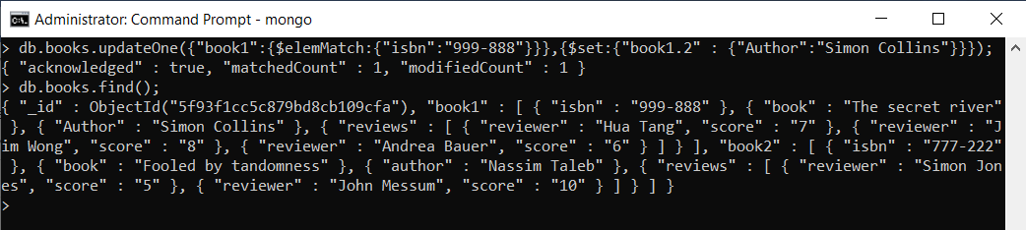

Command used:

> db.books.updateOne({"book1":{$elemMatch:{"isbn":"999-888" }}}, {$set:{"book1.2" : {"Author":"Simon Collins"}}});

What is upsert: upsert is special insert type or argument that allows data to be inserted if not found by the update criteria

In simple words : if found change it, if not found insert a new one.

Syntax: {$set: {}, {upsert:true}}